Project I

Documentation

Atakan Çiçek | 150140024

Furkan Çakır | 150150140

Hakan Eröztekin | 150130113

TABLE OF CONTENTS

Project Summary 3

Tools 3

How it works? 3

Commentaries 3

Atakan 3

Furkan 3

Hakan 3

Workload 3

Personal 3

Team 4

# Project Summary

The core motive of the project is to teach elementary school kids maths in gamified, more colourful and in mobile way. Our approach progressed through creating a mobile game using a game engine.

Contents of the project are divided into three subtopics that each person of our group is responsible for one subtopic. This way we’ve both distributed content workload amongst team members and also entailed three different teaching approaches to emerge.

# Tools

* **Unity** as a game engine,
* **Git** for version control,
* **Git Terminal** and **Sourcetree** as version control tool,
* **iOS** as mobile testing tool,
* **Microsoft Word 2013** as a report preparing tool.

# Storyboard

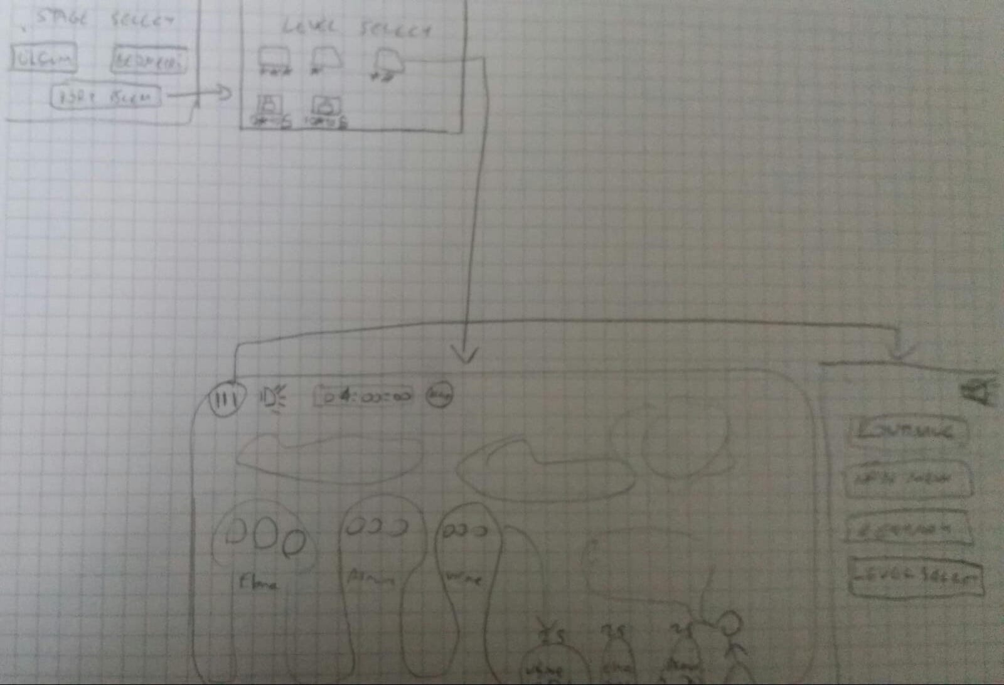

# Commentaries

## Atakan

I already had experience with Unity so the project helped me refresh that knowledge. Designing for kids was a challenge since the game had to be easy to understand but the levels had to be getting harder to challenge the kids. We used colorful assets to take the attention of the kids.

## Furkan

## Hakan

In this project, it was a quite opportunity for me to experience a game development with Unity. It is also a quite challenge because depth of Unity is far beyond of couple of tutorials. Because of that reason, it took great amount of time for us to find a good source. Luckily, Atakan was very knowledgeable about Unity and the process became smoother with his lead.

# Workload

## Team

As a group, we have gathered together four times.

We designed level and notification system together. We designed levels personally.

|  |  |  |  |
| --- | --- | --- | --- |
| # | date | aım | Hours |
| 1 | 24.09.18 | To sketch out the plan for the project | 1 |
| 2 | 01.10.18 | To determine the further steps and implementation details | 1 – 1,5 |
| 3 | 13.10.18 | To develop the common contents | 4 |
| 4 | 14.10.18 | To finish up the segments | 3 |

## Personal

Atakan: Implementation of menus, notification and geometry part.